Club Events Grant Semester 2 2024
Introduction
The Notre Dame Student Association (NDSA) has successfully applied for increased clubs funding through the SSAF Governance Committee. This is in two parts, a general increase in annual funding and through an event specific grant. This event specific grant will allow clubs to run more events, bigger and better than before! Clubs will be eligible to apply for $1000-5000 in semester 2 2024 per on-campus or off-campus event via this grant.
The NDSA reserves the right to solely approve, deny, alter the funding amount or place special conditions of any club event grant. In all cases of denial, alteration or placement of special conditions on grant applications, reasonable explanation will be given.
Essential Criteria
- Active and affiliated student club. The NDSA is ineligible to receive this funding except when there is a school without an active and affiliated club to host an event for them. In this case the NDSA may be able to host it in conjunction with a non-affiliated club or on the school’s behalf.
- Transfer of funding will be subject to the club providing evidence of final university event approval.
- Clubs must use the attached SSAF and NDSA logos in all marketing material and include the slogan “This event is supported by the NDSA through the SSAF” in marketing descriptions.
- Clubs must provide evidence of event and marketing plan to promote student uptake and engagement. This is done to provide insurance that the funding will go towards a well thought out event.
- Clubs must submit a report on the event within one week of its finishing or they may be ineligible to receive any future funding from the NDSA. The NDSA will provide a template for clubs to follow.
Desirable Criteria
Funding approval and amount will be based on the below criteria:
- On campus vs off campus, with preference given to events that are on campus to further attract people to come and stay on campus.
- Graduating student preference in semester 2 2024, with preference given to events catered towards graduating students.
- Ratio of funding to number of students impacted, with preference given to events that have a higher funding to student impact ratio.
- Proposed use of funding. The requesting club must show evidence that this funding will be used to decrease the cost of an event to students or increase the service or amenities that the event will provide (eg. addition of a photobooth without an increase in the cost of a ticket). In the case of free or fundraising events, it must increase the impact the event has (eg. upscaling the quantity of free food provided) rather than contributing towards the profitability of the event.

Application Procedure
- Club to plan event and apply for funding by submitting this application to clubs@ndsa.com.au

  - The NDSA will consider the application and approve, deny, alter the funding amount or place special considerations on the grant application in the next fortnightly council meeting. The NDSA will notify the club of this decision within 2 business days after.
  - Club to apply for event approval with the university
- Club to advertise/ market the event using required marketing outlined in “Essential Criteria”
- Upon receipt, club to forward university event approval to clubs@ndsa.com.au and treasurer@ndsa.com.au
- The NDSA Treasurer will transfer the funds to the nominated bank account
- Within one week of the event finishing the club must submit the post event report

Name of Club:
Name of Person Applying
Contact Email:
Nominated Bank Account: |  |  | Name of Account:  Account Number:  BSB:
Name of Event:
Date and Time of Event:
Event Location:
Expected Attendance: (Can be a range)
Description of Event:
Describe your event and how it relates to the essential and desirable selection criteria. Remember to provide a breakdown of:
- What specifically this funding will pay for (eg. $800 will be used to fund a photobooth, $500 towards catering. Providing quotes/ invoices from venues will help with your application!)
- How it will reduce the cost to students/ improve the event
- Marketing plan
- Graduating vs current student event

Last Day to Submit Event Report: (One week post event)
I [First name, last name] have read the above terms and conditions to applying for, receiving and using the funds available through the NDSA Club Events Grant and agree to abide by them. The information I have supplied in this application is a true and accurate representation of the planned event. I agree to submit a post event report using the NDSA Club Funding Report template within one week of the conclusion of the event.

Name:

Position in Club:
Signature
NDSA ONLY:
APPROVED |  | DENIED |  | AMMENDED
Date of Decision:
Comments if Denied or Amended:

NDSA and SSAF Logo’s to be Used:
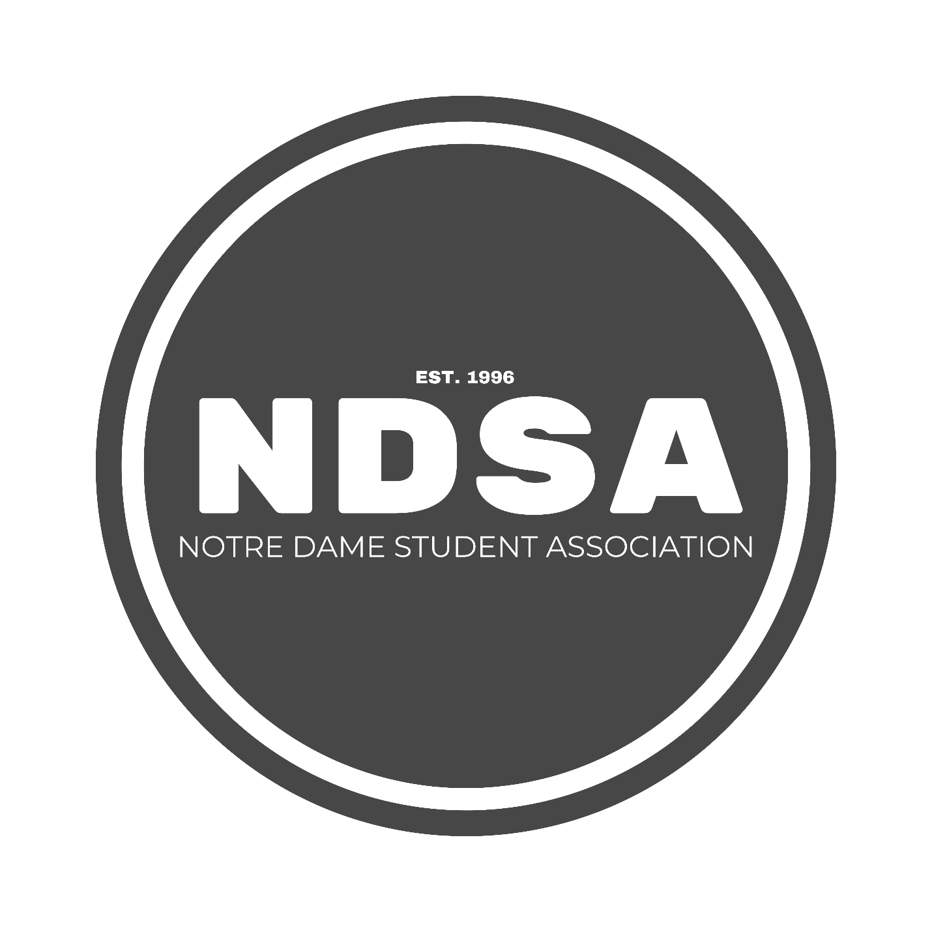
Please note as the University has not yet provided us with their SSAF logo we have temporarily removed the requirement to include the SSAF logo in marketing. Clubs will still be required to use the NDSA logo and the provided slogan above in marketing. If the word “SSAF” is easy to include in marketing posters or images, then clubs are encouraged to include this as well, but it is not a requirement currently.

